**SAP Transport Directory:**

* It is the global transport directory (/usr/sap/trans), which is actually a shared location (residing in the Domain Controller System) among all the member systems of a landscape (system group). It also contains certain subdirectories, that are created automatically during the installation of the SAP system. This is mandatory for setting up the Transport Management System.
* Basically, Transport Directory is the location where all the changes are saved (in the form of files) after they are released from DEV. Therefore, it acts as a source for the changes to be eventually imported in QAS and PRD. Hence, we have to make sure that the transport directory is shared properly among all the systems in a landscape.

As an example, in Windows NT, the shared directory location can be accessed using the following address: **\\<SAPTRANSHOST>\sapmnt\trans** where SAPTRANSHOST (Domain Controller System's address) is defined in the host's file in Windows Directory of all SAP systems in the landscape. Domain Controller – is one of the systems in a landscape that acts as an overall controller for change management and transport process in the landscape. Domain Controller is chosen (out of D / Q / P) by the team of system administrators, on the basis of system availability and the time of installation.

**Main Subdirectories:**

* **Cofiles:** Contains Change Request Information files with complete details and commands.
* **Data Files:** Contains the actual values and data to be used in implementing the change.
* **Log:** Contains Transport logs, traces or statistics, used for troubleshooting, in case any error occurs in the transport process.
* **EPS:** Download directory for advanced corrections and support packages

[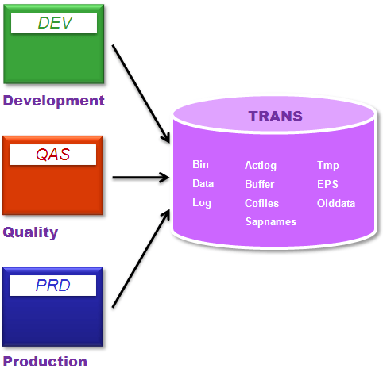](https://www.guru99.com/images/sap/2013/05/050813_0640_TransportMa7.png)

**Other Subdirectories are:**

* **bin:**Configuration files for tp (Transport Program) and TMS
* **old data:**Old Exported Data for archival or deletion
* **actlog:**Action logs for all requests and tasks
* **buffer:**Transport buffer for each system declaring the transports to be imported
* **sapnames:** Information regarding transport requests made by respective users
* **tmp:**Temporary and data log files

**Setting up of Transport Directory and TPPARAM**

* While configuring TMS, one of the main pre-requisite is to setting up the Transport Directory and the Transport Parameter file.
* It ensures that the Directory is shared properly among all the systems in a Landscape, for that all the systems taking part in the group/landscape are to be included in the global configuration file TPPARAM (transport parameter file), located under the **bin** subdirectory of /use/sap/trans. We have to make sure that the entries for all the participating systems are made in this file.
* In case, any entry is missing, copy another system's entry and change the values (for instance, System ID, Host name)
* At the time of installation, transport directory & the sub-directories are created automatically, including an initially configured template of TPPARAM file.

**Operating System Tools - *TP and R3trans***  
  
***tp* – The Transport Control Program:**

* **tp** is the SAP program that administrators use for performing and planning transports between systems and also in upgrades of the SAP systems. This is used by the CTO and TMS.
* Actually, **tp** uses other special tools/programs and utilities to perform its functions. Mainly, it calls **R3trans** utility program. However, it also offers a more extensive control of the transport process, ensuring the correct sequence of the exported/imported objects, to avoid severe inconsistencies in the system, which may arise due to the wrong sequence.
* **tp** is located in the standard runtime directory of the SAP system: **/usr/sap/SYS/<SID>/exe/run**. It is automatically copied in the installation process.
* As a pre-requisite, the **tp** global parameter file (**TPPARAM**), must be maintained, specifying at least, hostnames of the systems taking part in the transport process.
* **tp** is mainly used for performing imports in target systems. It uses utilities called Import Dispatchers – **RDDIMPDP** & **RDDIMPD_CLIENT_<nnn>**, these are ought to be scheduled as background jobs in every system where imports will be performed. If for any reason they are deleted, we can schedule these jobs by running report **RDDNEWPP**.
* These jobs are actually "*event triggered"*, meaning that **tp** sends a signal (an event) to the R/3 system and the job starts. These events are named as **SAP_TRIGGER_RDDIMPDP** and **SAP_TRIGGER_RRDIMPDP_CLIENT**.

**R3trans – The Transport Control Program:**

* **R3trans** is the SAP system transport program that can be used for transporting data between different SAP systems. It is normally not used directly but called from the **tp** control program or by the SAP upgrade utilities.
* **tp** controls the transports and generates the r3trans control files, but does not connect to the database itself. All the "real work" is done from **R3trans**.
* It supports the transporting of data between systems running on different OS and even different DB.